ZONTA BREAST CUSHIONS

In 1994, the Zonta Club of Botany Bay (south of Sydney) developed the breast care cushion. The idea came from a club member who had been given a curved cushion by a friend following a partial mastectomy and found that it provided comfort whilst sleeping. A second club member, Ann Selle OAM, designed the Zonta cushion with the input of nursing staff. The making and distribution of these cushions then became a club service project and in 2001 became a national service project of Zonta Clubs throughout Australia - thousands of women have benefited from receiving such a gift.

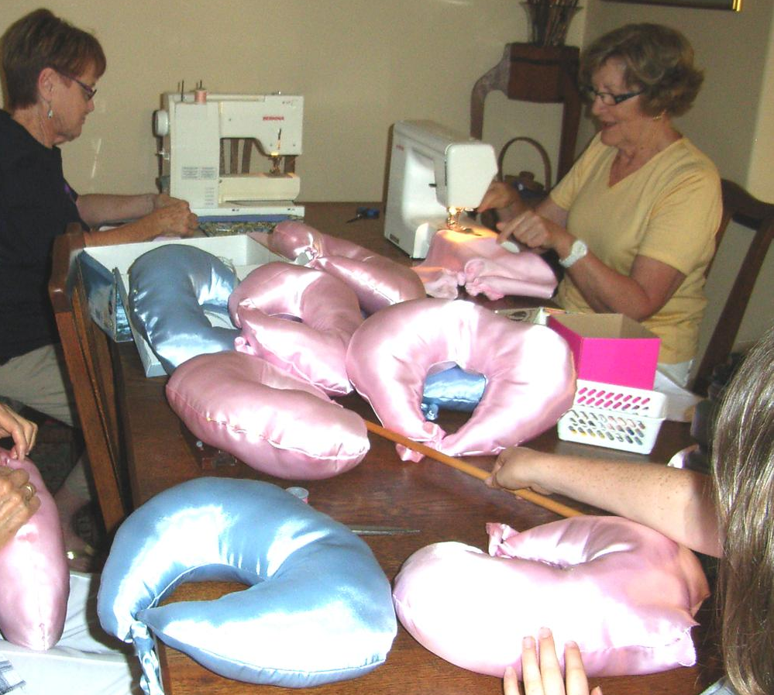
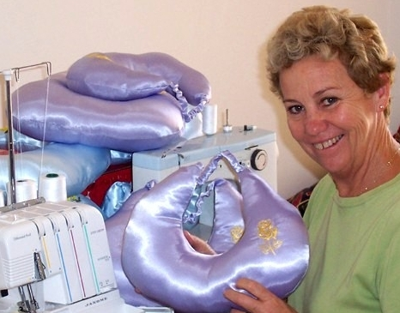
Zonta Club of Perth Northern Suburbs –workshop

The cushion provides comfort and protection to women (and men) in the post-operative phase of breast surgery. They are produced by Zonta members, associated craft groups and Bandyup Women’s Prison (as a community service in association with WA Zonta Clubs). The costs of this project are met by Zonta Clubs through fund-raising and donations of materials and gifts from grateful recipients. Cushions are supplied to metropolitan and country hospitals and cancer support groups and distributed in hospitals by Breast Care Nurses. In Western Australia alone over 1,000 cushions are distributed each year.

Zonta International – www.zonta.org
Zonta Club of Swan Hills – www.zontaswanhills.org.au

